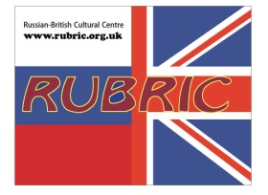
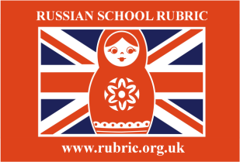
RUBRIC
RUSSIAN
SCHOOL
Application Form – Russian for Adults
Family Name
First Name
Nationality
Date of Birth
Address
Telephone number(s)
E-mail
Skype
Next of kin contact (in case of emergency)
Why have you decided to learn Russian?
Did you learn Russian before?
Where and for how long?
What do you think about your level of Russian?
- I haven’t learnt Russian yet
- I am a beginner (I speak slowly and I struggle to understand)
- I have an intermediate level (I speak but I make a lot of mistakes)
- I have an advanced level (I speak fluently but with mistakes)
Which aspects would you prefer more at the lessons (speaking, writing, listening, reading)?
What do you expect to achieve by the end of your course?
Have you got some specific requirements to the course?
How did you find out about the Russian school RUBRIC?

